Tasks:

# | Task | Classification | Why
1 | Build and improve Python projects | Collaborate with AI | AI can help me brainstorm, debug, and explain code, but I make the final decisions.
2 | Debug Python errors | Collaborate with AI | AI can help find and explain errors, but I test the solution myself.
3 | Learn machine learning concepts | Collaborate with AI | AI can explain difficult concepts and examples, while I make sure I understand them.
4 | Work on ML projects such as Iris Classification and Fraud Detection | Collaborate with AI | AI can help with coding and troubleshooting, but I evaluate the model and results.
5 | Perform EDA and feature engineering | Collaborate with AI | AI can suggest analysis ideas, but I decide which methods are appropriate.
6 | Work on data science projects such as Customer Segmentation and Pakistan Economic Indicators | Collaborate with AI | AI can support coding and interpretation, but the project decisions are mine.
7 | Improve GitHub repositories and README files | Delegate to AI with review | AI can help draft documentation, but I check the technical information before publishing.
8 | Improve my LinkedIn profile and project descriptions | Delegate to AI with review | AI can suggest professional wording, but I decide what accurately represents me.
9 | Write LinkedIn posts about my projects | Delegate to AI with review | AI can create a draft, but I check the technical details and personal message.
10 | Complete online courses and certifications | Just me | I need to personally study, understand the material, and complete the assessments.
11 | Decide which projects to build and which features to add | Just me | These decisions depend on my interests, goals, and what I want to learn.
12 | Create game ideas and features for projects such as Snake Game and Neon Vendetta | Collaborate with AI | AI can brainstorm ideas, but I decide what fits my project and test the implementation.
13 | Prepare projects for my portfolio and internship | Collaborate with AI | AI can help improve presentation and documentation, but I decide what work to showcase.
14 | Learn new programming tools, libraries, and workflows | Collaborate with AI | AI can explain tools and examples, but I need to practice and verify them myself.

Claude Account:

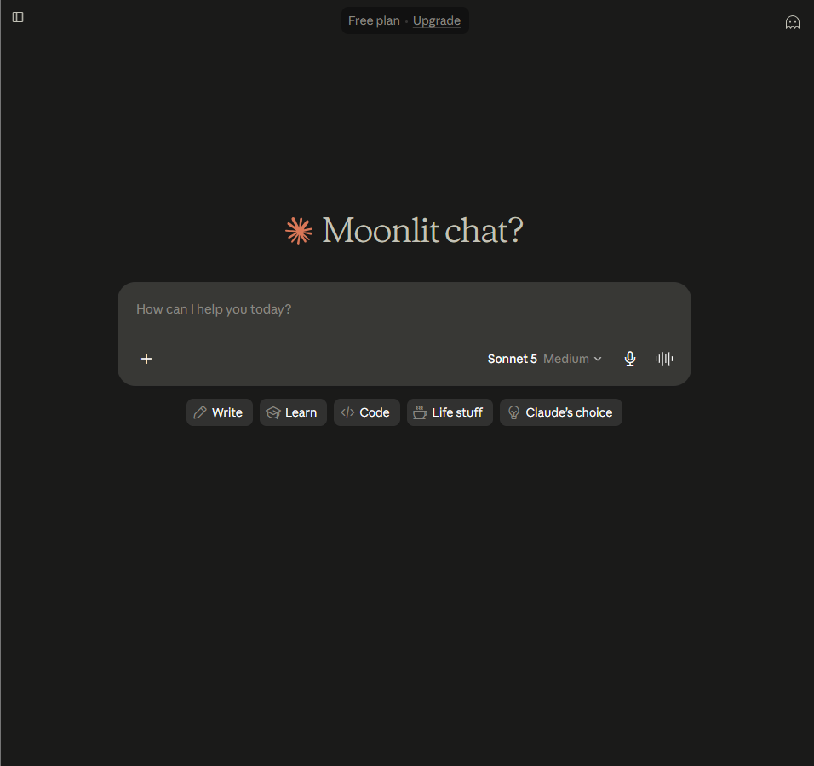

ChatGPT Account:
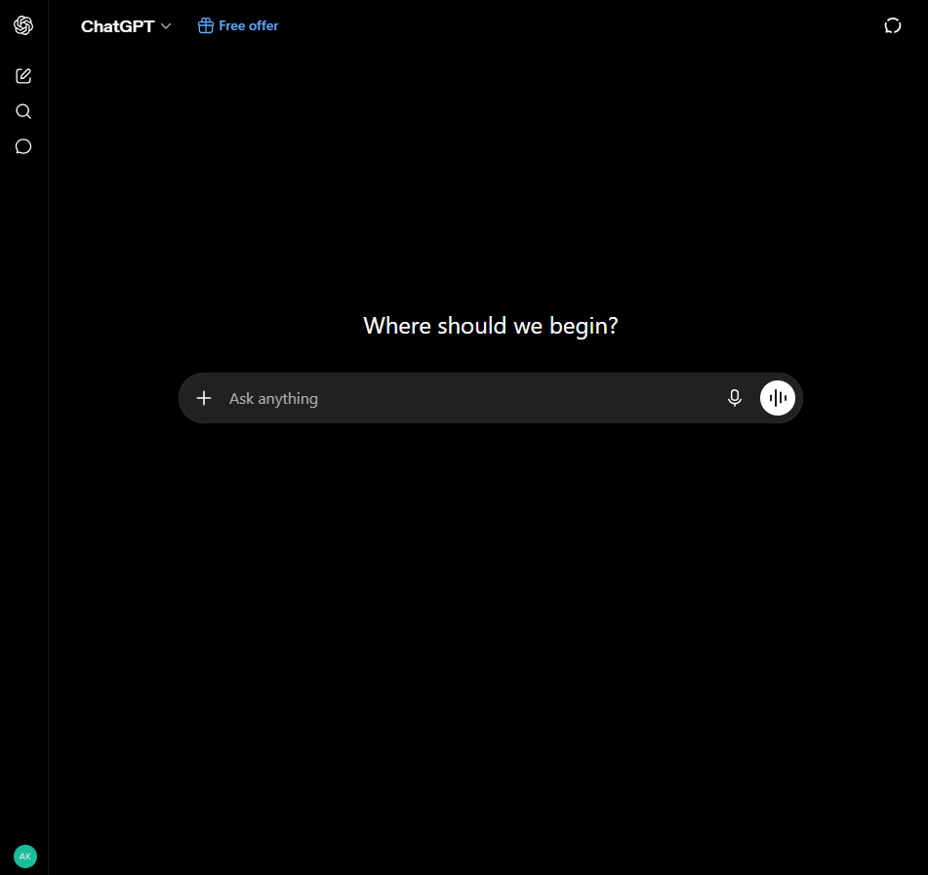
Anthropic Account:
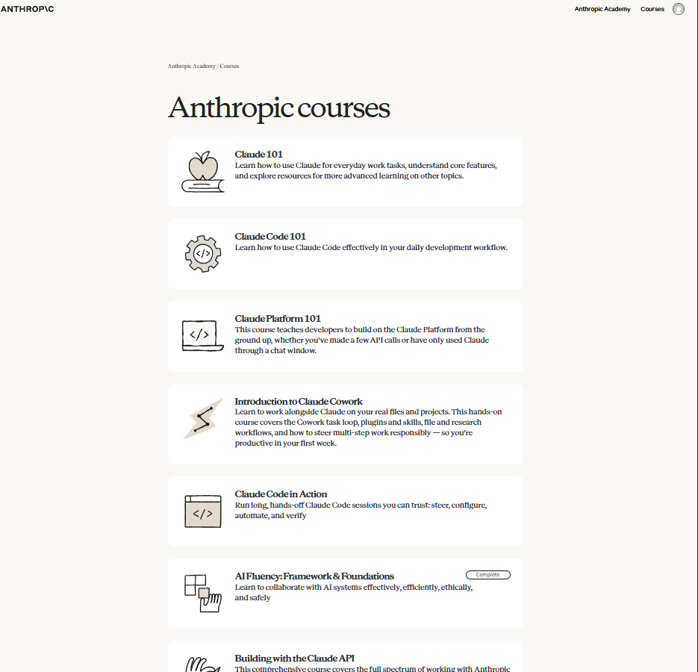
AI Fluency: Framework & Foundations completed:
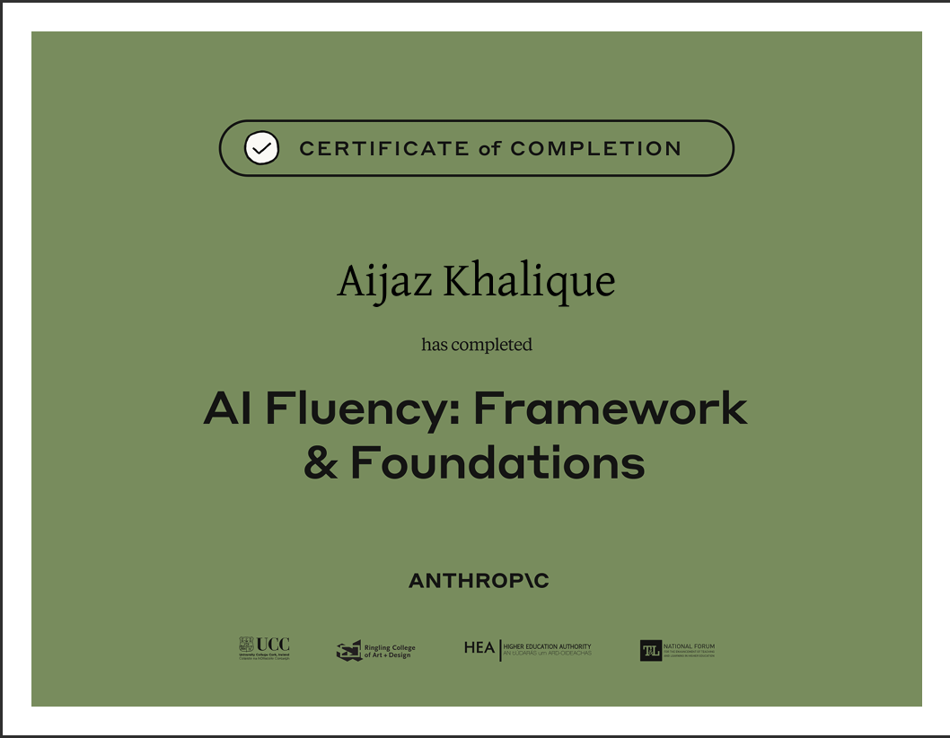

Claude Project created:
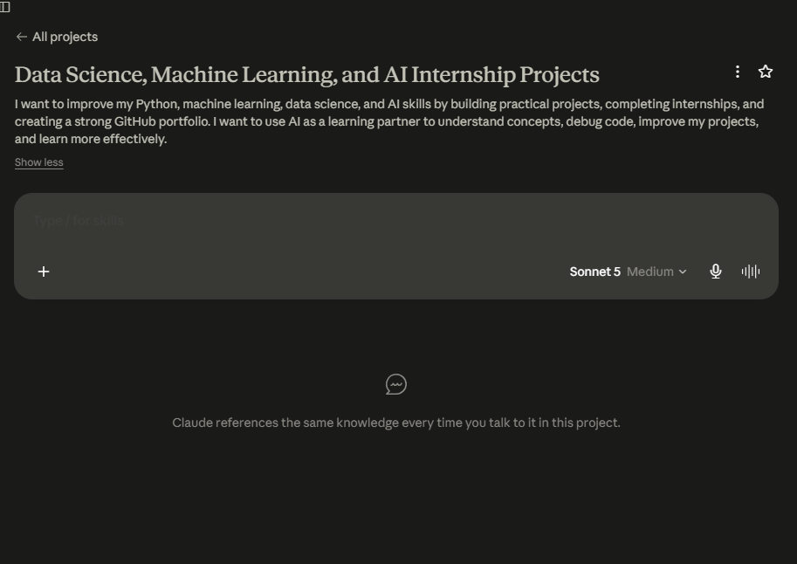
Custom Project instructions added:
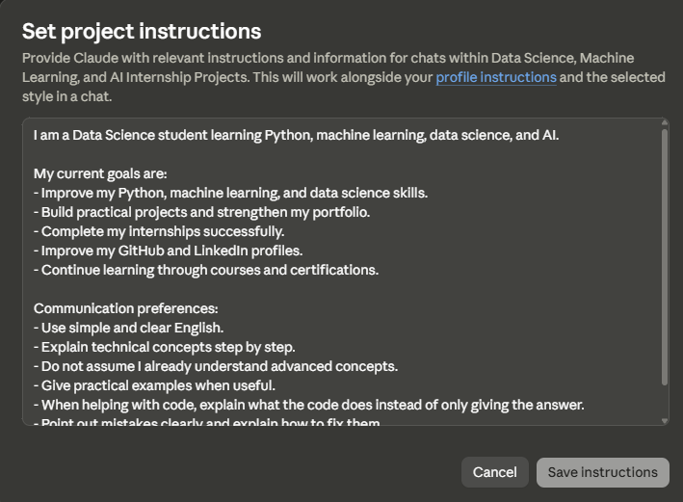

Three target tasks selected:
1. EDA & Feature Engineering
Done well means: I can explain why I used the main EDA techniques and selected features, and my analysis produces clear and useful findings from the data.
2. Build & Improve Machine Learning Models
Done well means: The model runs correctly, I understand the main steps, I can explain the evaluation results, and I can justify why I chose the model.
3. Learn New ML Tools, Libraries & Workflows
Done well means: I can use the new tool or library for a small ML task independently and explain its basic purpose without simply copying AI-generated instructions.

